

**College of Computer and Information Sciences**

**Department of Information Systems**

**IS 466: Decision Support Systems Project Report**

**1st Semester 2019**

**Decision Support Systems Project**

|  |  |
| --- | --- |
| Student name | SID |
|  |  |
|  |  |
|  |  |

Contents

1. Abstract 2

2. Introduction 2

3. Snowflake Schema 2

4. OLAP Operations 3

5. All Levels of Dimension Hierarchies 8

6. References 8

Table of Figures

Figure 1: Snowflake Schema 3

Figure 2: Drill Down SQL Format 4

Figure 3: Drill Down SQL Server 5

Figure 4: Roll Up SQL Format 6

Figure 5: Roll Up SQL Server 6

Figure 6: Slice SQL Format 7

Figure 7: Slice SQL Server 7

Figure 8: All Levels of Dimension Hierarchies 8

# Abstract

The project is about creating and processing data cubes in the database. In this project we should do four steps based on Project Requirement as following:

1. The full snowflake schema for the shops supply cube.
2. Query samples for the OLAP operations in SQL format & SQL Server.
3. Table that display information of supply quantity by considering all levels of dimension hierarchies.
4. Example of OLAP operations by using MDX query language.

So, in this project we will consider of all those steps.

# Introduction

We created the first step snowflake schema by using SQL Server Data Tools. Tools that we used in our project are as following:

1. SQL server 2008 (for generating and creating the database).
2. SQL server management studio 2012 for creating our schema and Analysis Manager).
3. SQL data tools (for creating the data cube).

# Snowflake Schema

Snowflake Schema is type of multidimensional model which is used for data warehouse. In snowflake schema, the fact tables, dimension tables as well as sub dimension tables are contained. This schema forms a snowflake with fact tables, dimension tables as well as sub-dimension tables. [See Figure 1]

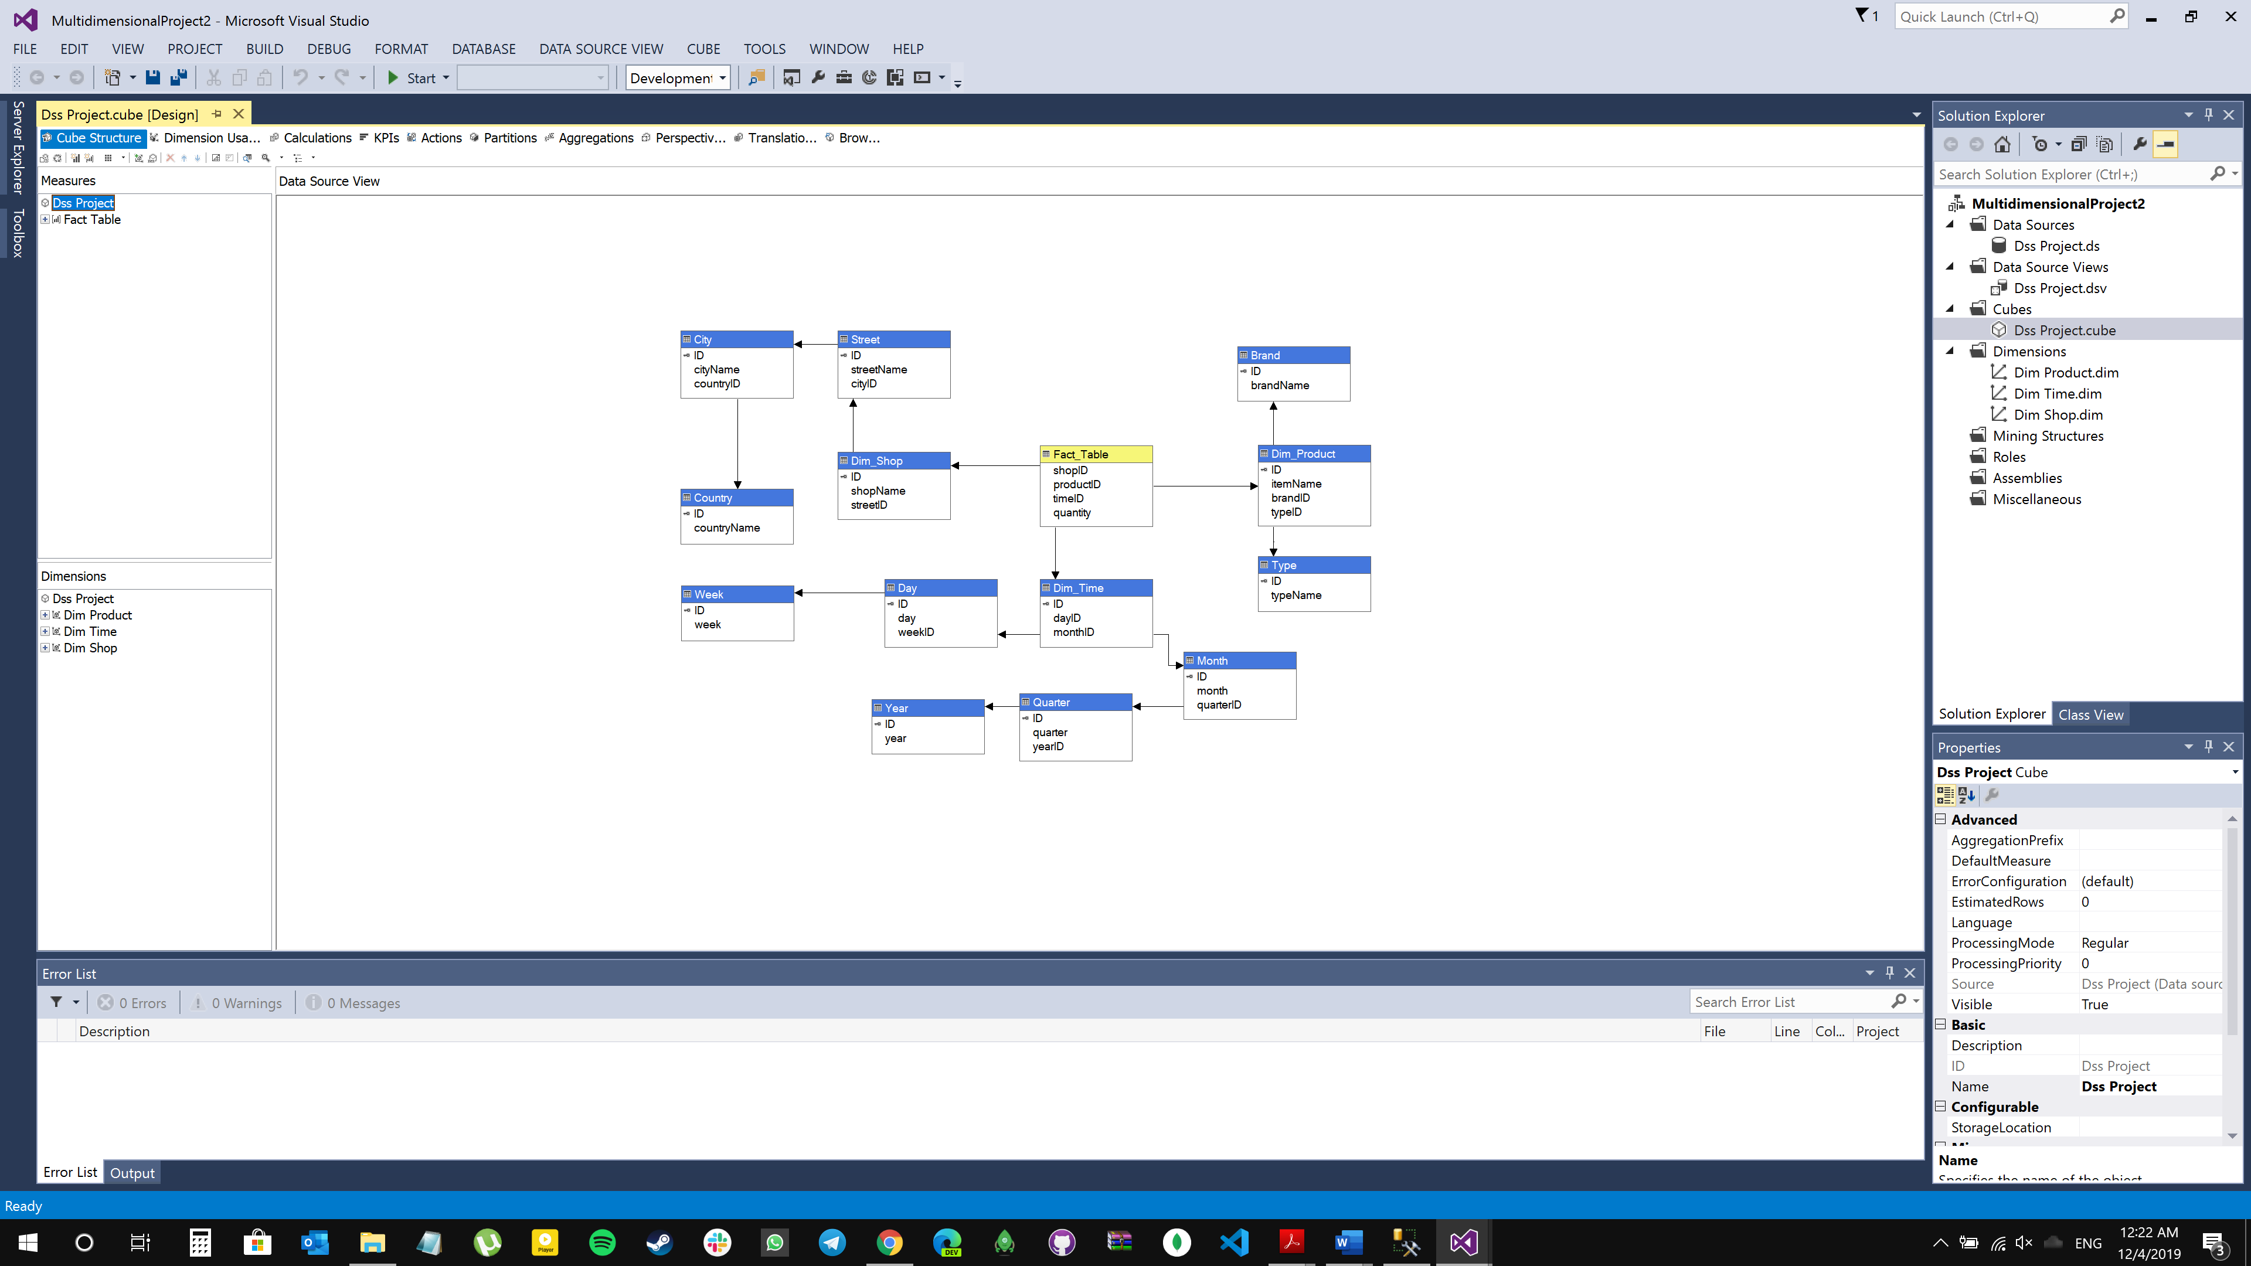

Figure 1: Snowflake Schema

# OLAP Operations

We have three type of OLAP operations drill-down, roll-up, and slice. For each operation we will do a query samples in SQL format and under Analysis Manager of SQL Server 2008.

* 1. Drill Down

This is a reverse of the ROLL UP operation discussed above. The data is aggregated from a higher level to a lower level data. [Please see Figure 2&3]

* + 1. SQL Format

Select Dim_Shop.shopName , City.cityName ,Dim_Time.ID as TimeID , Dim_Product.itemName,

Type.typeName, Sum(Fact_Table.Quantity) as Quantity

from Dim_Shop , Dim_Product, City, Dim_Time ,Fact_Table, Street, Country, Type

Where Dim_Shop.ID = Fact_Table.shopID AND Dim_Product.ID = Fact_Table.productID AND

Dim_Time.ID = Fact_Table.timeID AND Street.ID = Dim_Shop.streetID AND

Country.ID=city.CountryID AND Street.CityID = City.ID AND Type.ID = Dim_Product.typeID

GROUP By Dim_Shop.shopName,City.cityName, Dim_Time.ID , Dim_Product.itemName, Type.typeName

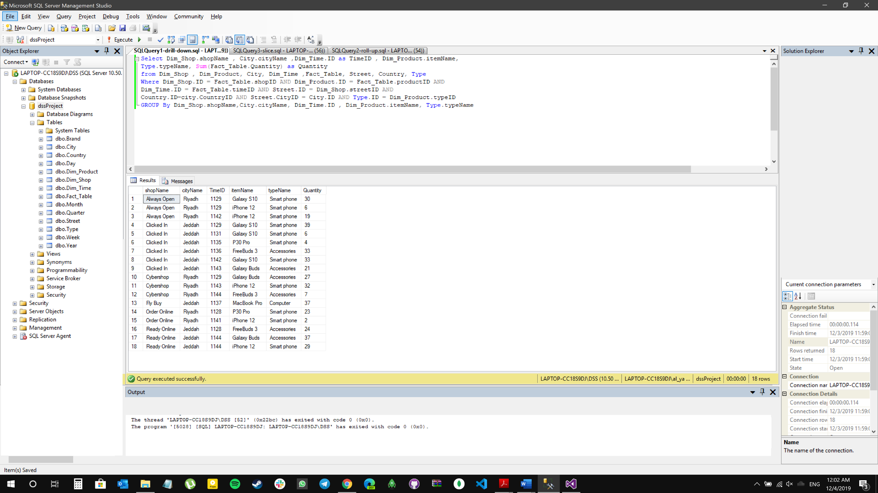

Figure 2: Drill Down SQL Format

* + 1. SQL Server

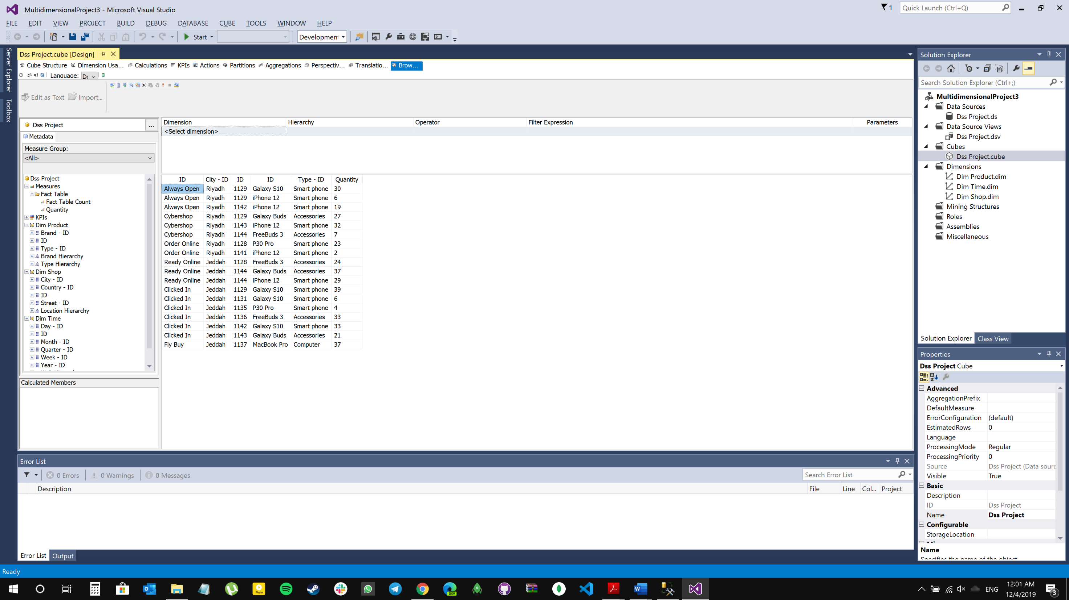

Figure 3: Drill Down SQL Server

* 1. Roll Up

ROLLUP is used in tasks involving subtotals. It creates subtotals at any level of aggregation needed, from the most detailed up to a grand total i.e. climbing up a concept hierarchy for the dimension such as time or geography.

* + 1. SQL Format

Select Dim_Product.itemName , SUM(Fact_Table.quantity)

from Dim_Product , Fact_Table

where Dim_Product.ID = Fact_Table.productID

Group By Dim_Product.itemName [See Figure 4]

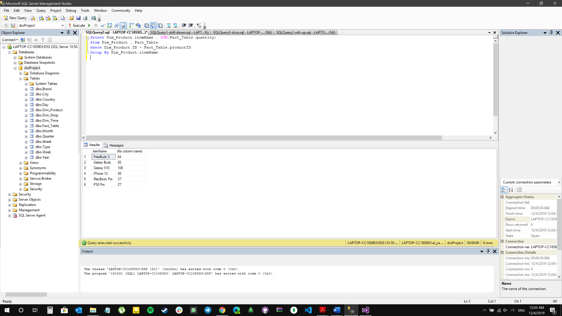

Figure 4: Roll Up SQL Format

* + 1. SQL Server

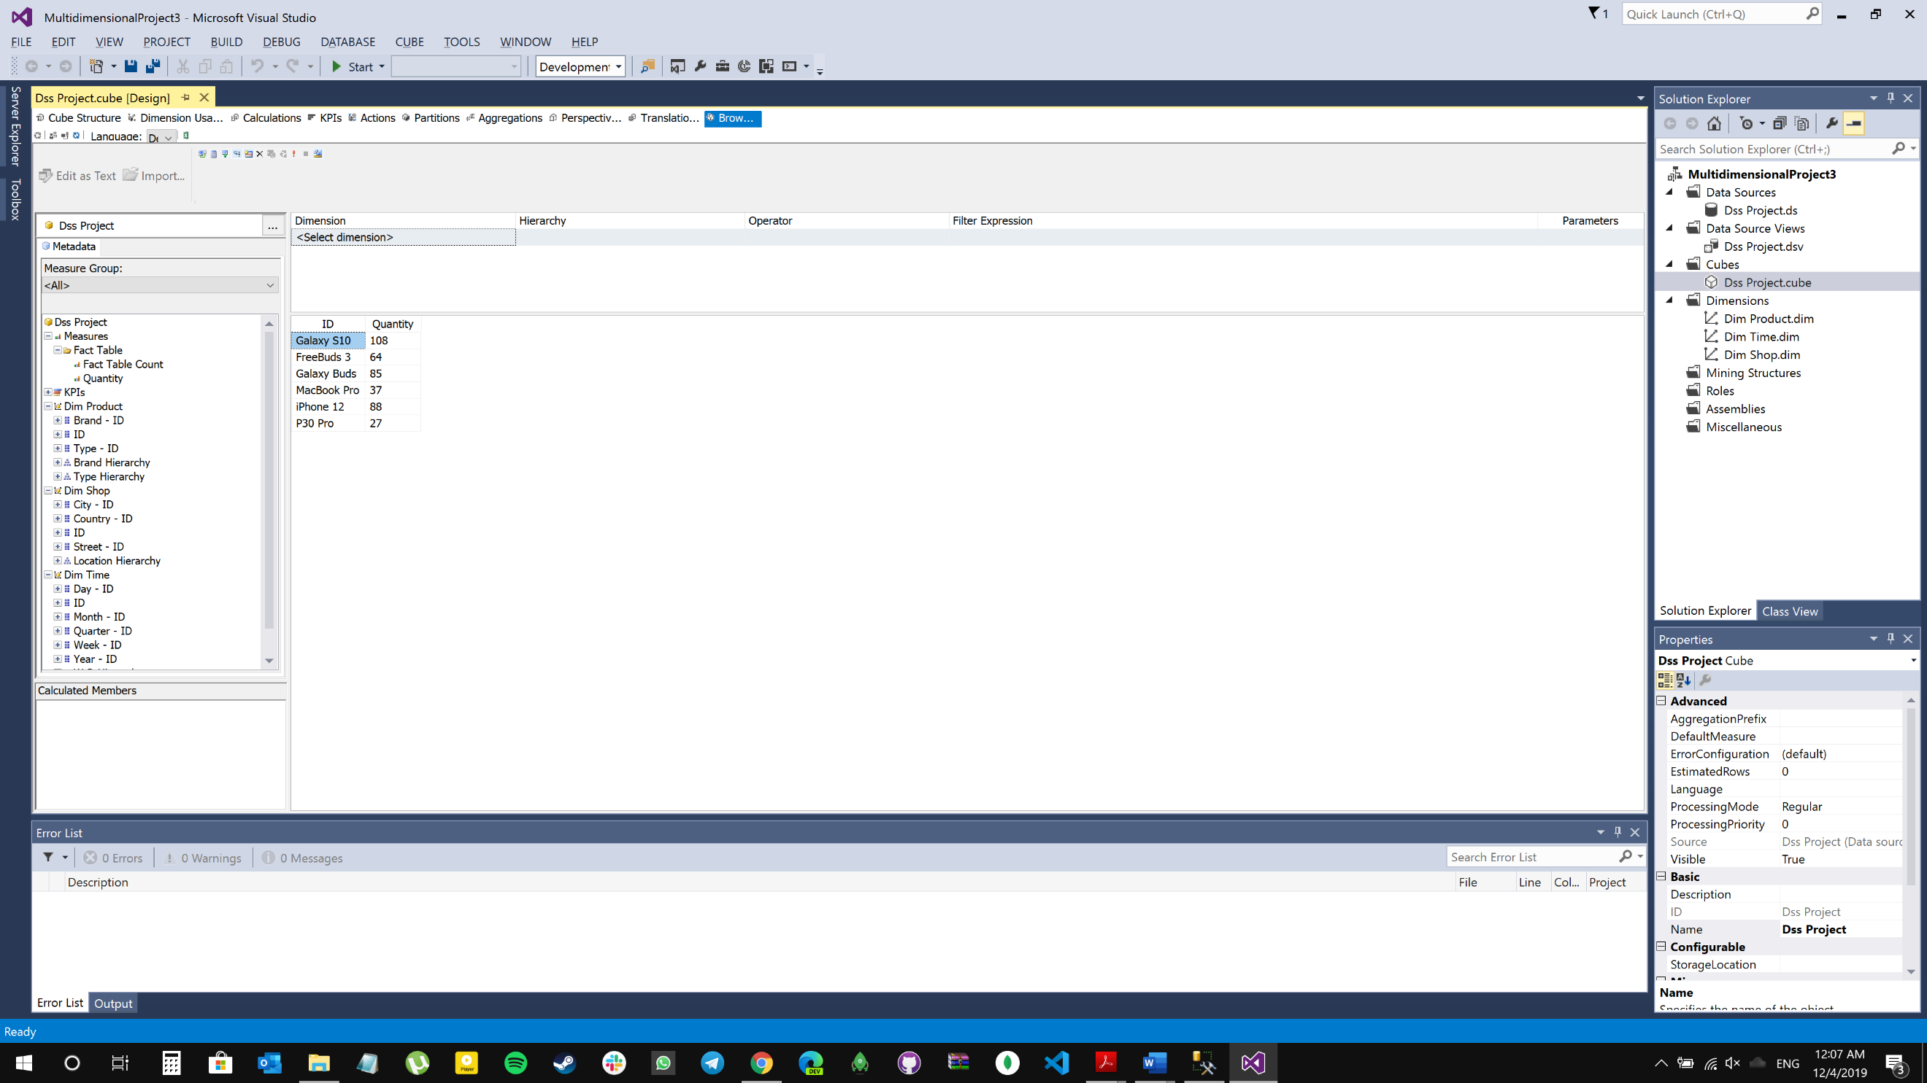

Figure 5: Roll Up SQL Server

* 1. Slice

A slice in a multidimensional array is a column of data corresponding to a single value for one or more members of the dimension.

* + 1. SQL Format

Select Dim_Shop.shopName , City.cityName , Dim_Time.ID ,Dim_Product.itemName, SUM(Fact_Table.quantity) as Quantity

from Dim_Shop , Dim_Product , Dim_Time , Fact_Table , City, Street, Country

where Dim_Shop.ID = Fact_Table.shopID AND Dim_Product.ID = Fact_Table.productID AND Dim_Time.ID = Fact_Table.timeID AND

Street.ID = Dim_Shop.streetID AND Country.ID=city.CountryID AND Street.CityID = City.ID AND

Dim_Shop.shopName = 'Always Open'

Group By Dim_Shop.shopName, City.cityName, Dim_Time.ID , Dim_Product.itemName [See Figure 6]

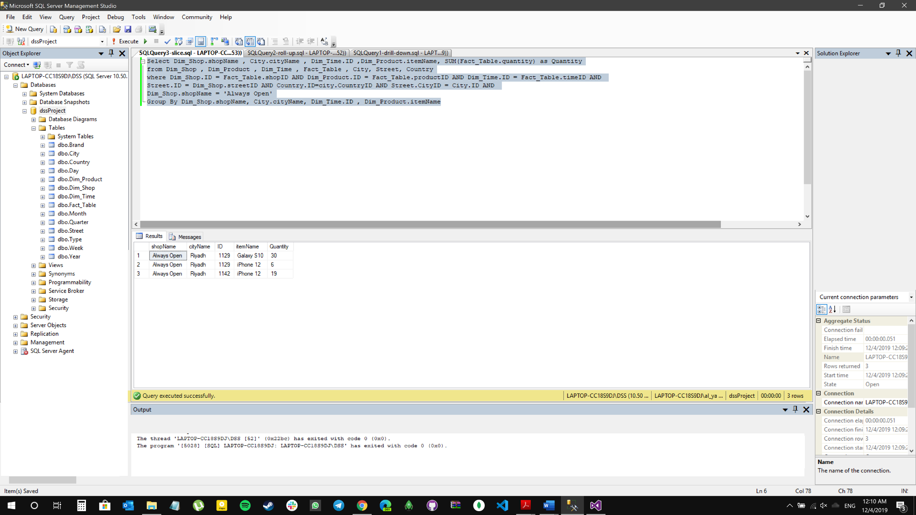

Figure 6: Slice SQL Format

* + 1. SQL Server

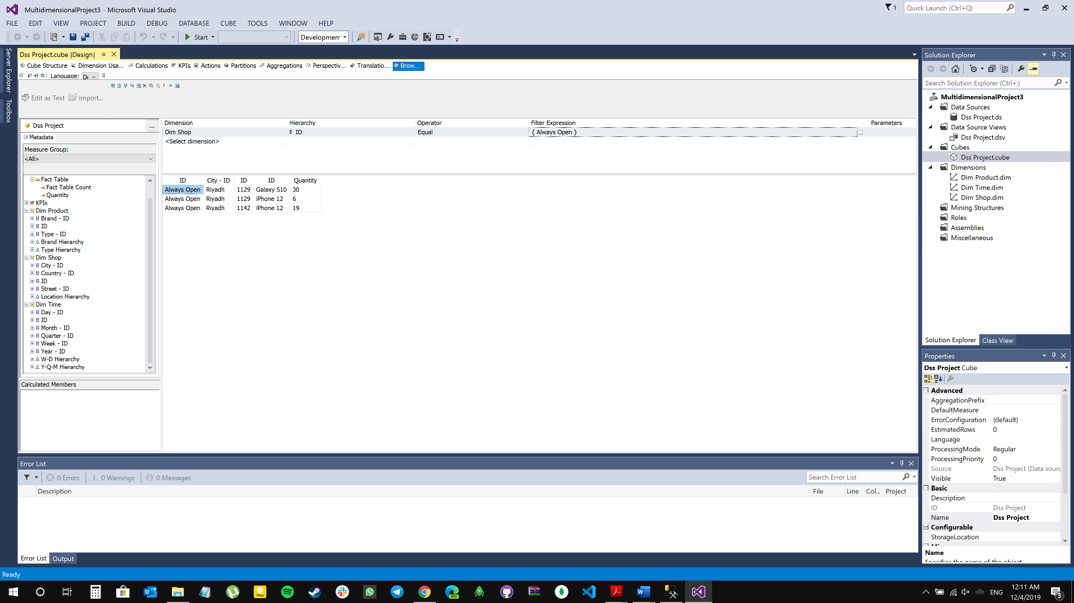

Figure 7: Slice SQL Server

# All Levels of Dimension Hierarchies

Overall look... all levels of the hierarchical dimension [See Figure 8]:

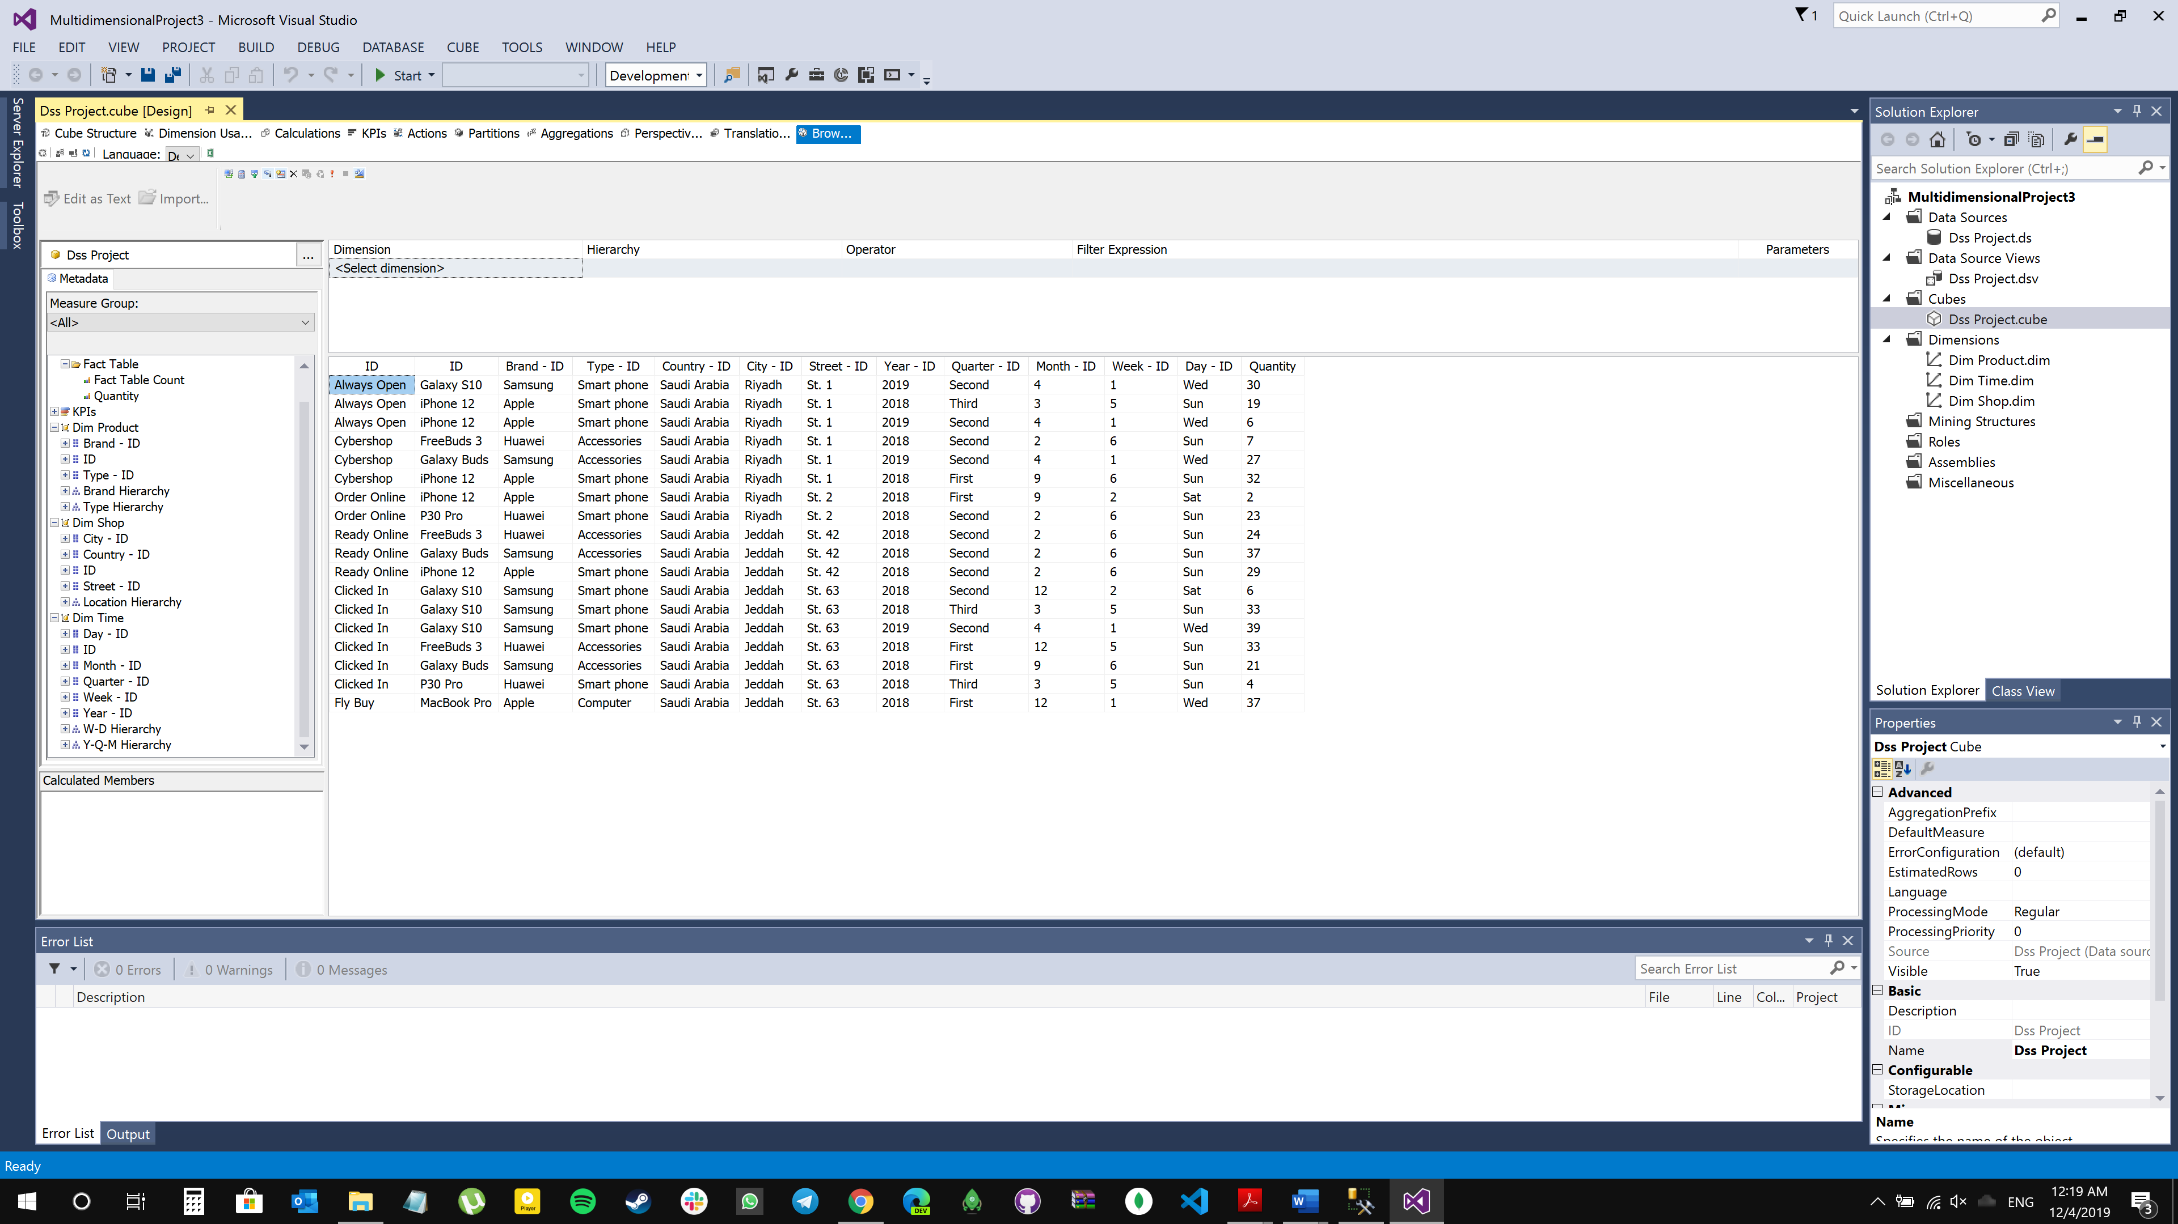

Figure 8: All Levels of Dimension Hierarchies

# References

1. <https://www.youtube.com/watch?v=wbqwSM26Y8o>
2. <https://blogs.perficient.com/2017/08/02/data-cube-operations-sql-queries/>
3. <https://www.youtube.com/watch?v=0ZMndP_Y32U>